Design Evaluation Outcome 1

Objective and Validation Metrics
The Interactive Prototype 1 tested two of the three core interactions defined in the Design Concept Report: filming with the camera, filter selection with the mirror, and the supporting tripod-placement interaction for hands-free recording, using a Unity horizontal prototype in VR. In the Design Concept Report, I assumed that TikTok-derived interface conventions, such as button presses, swipe-style browsing, grab-and-place, would be easily discoverable, usable and intuitive in XR though relying on the user's prior knowledge and mental models. However, through testing with users, this assumption became invalidated.
The test aimed to discover whether first-time users, given minimal instruction, could complete three tasks: starting/stopping recording; placing the camera on the tripod; and browsing/selecting a filter. The test also aimed to identify where they hesitated or made errors when interacting with the prototype.
Success in every task was defined as: task-completion (pass/fail); completion time; a 1–5 ease-of-use rating; qualitative think-aloud commentary; and observed hesitation/error points. Testing used a task-based usability test, think-aloud protocol and task-completion method, run with 5 participants against a paper logsheet (participant, task, time, success/fail, errors, think-aloud notes, ease-of-use rating, comments). Additionally, voice recordings were made of each test, and transcripts were created using AI tools to read user’s think-aloud comments (See Appendix B).

Results
5 participants attempted all 3 tasks (15 task attempts total). Full per-participant data is in Appendix A. A summary of the data can bee seen in the table below:
Table #1: Summarised Findings from IP1 Testing
Task | Success rate | Average ease (1-5) | Notes
1 – Start/stop recording | 5/5 (100%) | 3.3 | Consistently completed; ease dragged down by initial grab hesitation and one false-start read.
2 – Place camera on tripod | 1/5 (20%) | 1.4 | Clear failure point — grab/placement mechanic not discoverable for most first‑time users.
3 – Browse & select filter | 5/5 (100%) | 4.4 | Highest success and ease; residual issues in exit/confirm affordance and missing live preview.

- Task 1 - Record with camera: All 5 participants succeeded. However there existed a common friction of locating the camera before interacting with it; one participant even went to the filter station first. Additional frictions were working out how to grab it, and one participant briefly misreading an indicator as meaning recording had already started.
- Task 2 - Put camera on tripod: Only 1 of 5 participants succeeded, the only participant who self-reported strong prior VR-controller experience. The other four could not reliably pick up the camera and/or place it on the tripod; two asked for help, one returned to the VR home screen, and one could not pick up the camera at alll they all DNF. In the one time the task was completed, the tripod itself was reported as unstable, as it "fell over whenever it [the user] got too close".
- Task 3 - Change and apply filters: All 5 participants succeeded and this task had the highest ease ratings. However, there were residual issues, such as uncertainty about how to click/select and find Exit, no live filter preview shown on the mirror, and (for two participants who had failed Task 2, an inability to pick the camera back up afterward carried over into this task.

Analysis and Insights
● Button-press interactions transfer well. Task 1's record button and Task 3's carousel Next/Confirm/Exit buttons. With both similar to TikTok's UI conventions, these tasks were completed by everyone, supporting the original assumption for this class of interaction.
● Grab-and-place and spatial manipulation does not transfer intuitively. The tripod task, which depends on VR-specific grab and free-positioning gestures with no 2D-app equivalent, was the clear outlier: 80% failure and the lowest ease score by a wide margin. This is a genuinely different interaction class from anything in the source TikTok interface, so the assumption that TikTok interactions knowledge transfer over to the VR app does not extend to this task.
● VR-controller usage causes confusion. The one participant who passed Task 2 explicitly had prior controller experience; every other participant's Task 2 notes mention being "unfamiliar with VR controls" or asking for help with grabbing. This suggests some of the failure is general VR novice friction rather than a flaw specific to this task's design. However, this also shows that the task still needs to be more forgiving of that novice state of VR controllers.
● Discoverability, not comprehension, is the main barrier. Once participants found the right object or control (camera, filter carousel, exit), they generally understood what to do with it. The recurring failures are about locating/initiating the interaction ("looking for tripod", "went to filter instead of camera", "not sure how to grab"), not about understanding the task itself. It may be helpful to have directions in the VR environment to overcome this barrier.
● The mirror/filter station needs a completion loop. Multiple participants wanted to see the filter applied before/while confirming (no live preview was implemented in this prototype), and two participants' inability to pick the camera back up after visiting the mirror suggests the camera and tripod interactions aren't currently resilient to being revisited later in a session.

Evaluation of Aims
The testing objective, whether first-time users can complete the three tasks with minimal instruction, and where they hesitate, was met: the test surfaced a clear, consistent pattern across participants rather than noise.
The underlying assumption from the Design Concept Report, that TikTok-derived interface conventions transfer intuitively to VR gesture controls, is partially invalidated. It held for simple, flat, button-style interactions in Tasks 1 and 3. However, it did not hold for the tripod's spatial grab-and-place interaction in Task 2, which has no TikTok precedent and needed VR-specific affordances the prototype didn't yet provide. The assumption that "users have prior knowledge on using a camera, tripod and filters" was only true for real-world object familiarity, not for VR-specific manipulation of those objects.

Concept Iteration
● Add explicit grab affordance cues to the camera and tripod, such as an outline/highlight on proximity of object, a brief on-object prompt for the grip gesture so first-time users don't need to ask for help to initiate a grab. This directly responds to the recurring "unsure how to grab" finding across 4/5 participants.
● Replace free-form tripod placement with a snap-to-target placement zone, so the camera locks into a stable, correctly oriented position once brought near the tripod, removing the "tripod fell over" instability reported even by the one participant who succeeded. It may also be helpful to remove gravity/apply kinematic to the tripod so it does not fall over.
● Strengthen the recording-state indicator, with colour, motion or audio cue clearly distinct from idle, to resolve the false-start confusion in Task 1.
● Add a short, optional grab/interact tutorial before the three core tasks begin, so VR-novice users get one guided rehearsal of the grip gesture before being asked to use it unaided. This addresses the VR controllers confusion identified in the analysis without changing the tasks themselves.
● Implement the live filter preview on the mirror, which is not yet functional in this current prototype through a filter staging section, and extend the preview of the filter to the whole mirror surface per participant feedback, and clarify the Exit/Confirm button affordance in the carousel.
● Make the camera and tripod re-grabbable from a "dropped" or post-mirror state, so a user who has visited the mirror can still pick the camera back up without restarting or without significant difficulty.

Reflection on the Concept, Design, Methodologies and Future Testing
The think-aloud plus task-based method was effective at exposing exactly where the interface breaks down, as the log sheet's error/hesitation column made the tripod problem immediately visible as a pattern rather than an isolated result. Although there were only 5 participants, the tripod failure was consistent enough (4/5) that it's unlikely to be simply due to lack of VR controller knowledge and must be addressed in future iterations of the prototype..
One methodological gap in my testing is that participants' prior VR experience wasn't captured as a variable, even though it appears to explain most of the variance in Task 2 outcomes. For the next testing round, I would like to record each participant's self-reported VR familiarity beforehand and consider a brief warm-up or teaching basic interactions in order to separate general VR controller unfamiliarity from problems specific to this interface. I would also like to add a lightweight mid-task prompt option, instead of only full researcher intervention, so a participant who gets stuck can get an unobtrusive nudge without ending the task as a hard fail, giving slightly richer insights on partial progress.

Appendices

Appendix A.1: Raw Testing Data

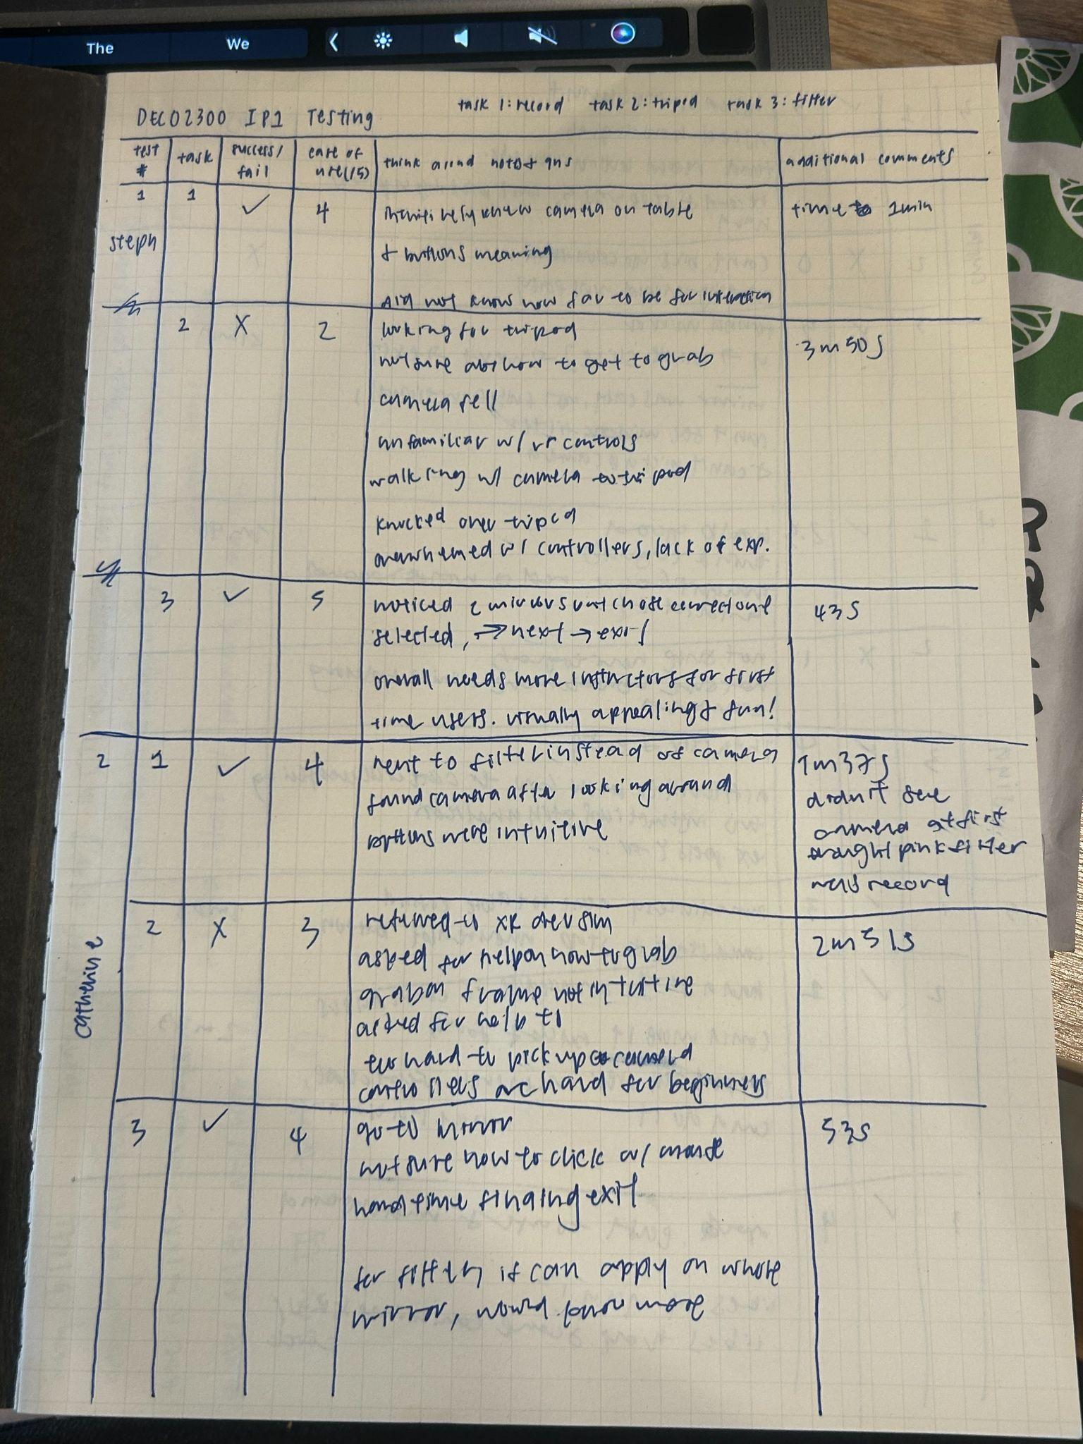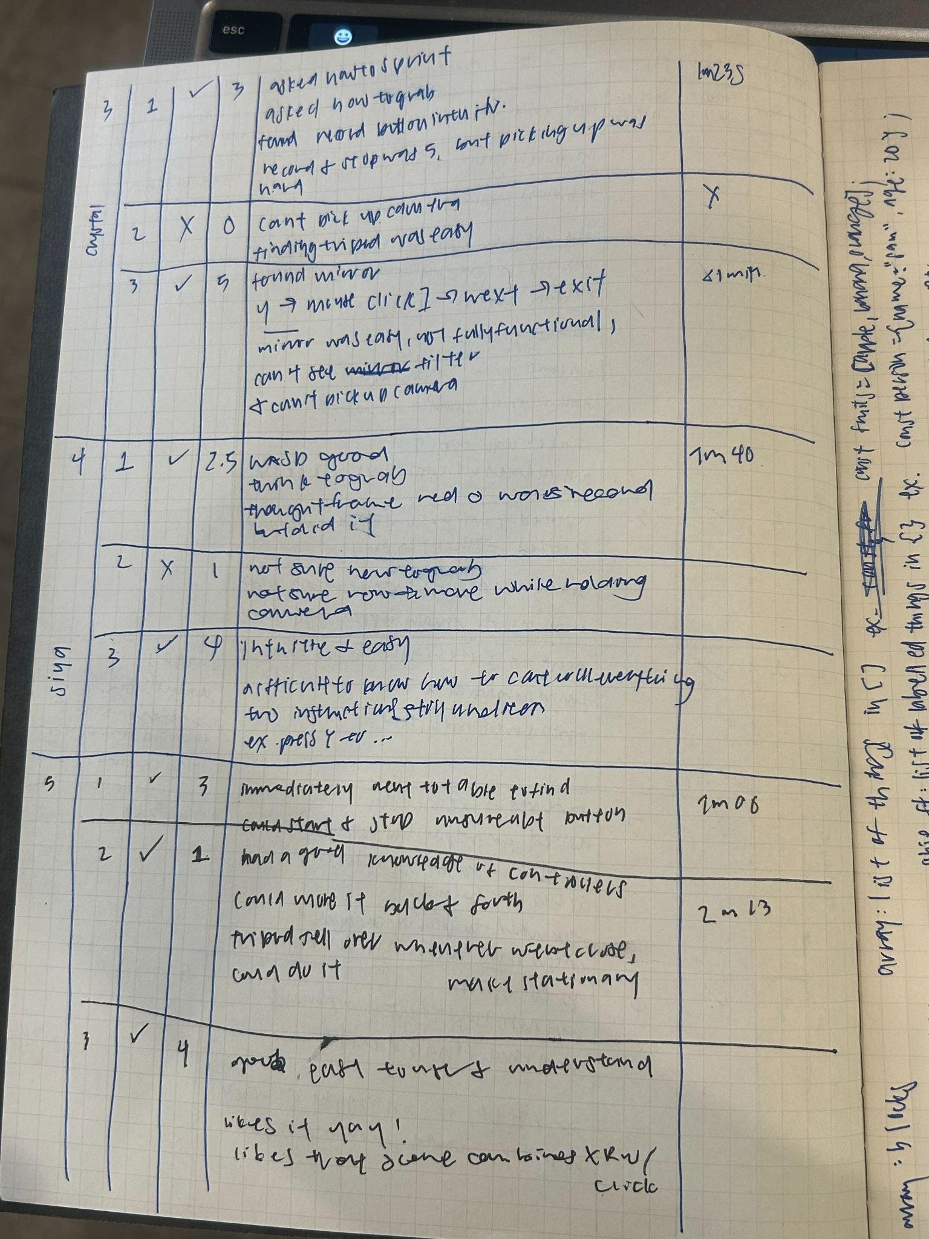

Appendix A.2: Raw Transcribed Testing Data
Transcribed directly from the paper log sheet used during testing.
T1: Record, T2: Tripod, T3: Filter. Ease 1-5, with 5 being the easiest.
Person | Task | Result | Ease (1–5) | Time | Notes / think-aloud
1 | T1 | Pass | 4 | ~1:00 | Already knew camera was on table & what buttons meant; unsure how far to stand for interaction to register.
1 | T2 | Fail | 2 | 3:50 | Searched for tripod; unsure how to grab; camera fell; unfamiliar with VR controllers; walked to tripod holding camera; knocked tripod over; overwhelmed by controls, low VR experience.
1 | T3 | Pass | 5 | 4:35 | Noticed the carousel switch but not fully clear it had changed; used Next → Exit. Needs more onboarding for first-timers; found it visually appealing and fun.
2 | T1 | Pass | 4 | 1:37 | Went to filter station before finding the camera; found it after looking around; once found, buttons felt intuitive.
2 | T2 | Fail | 3 | 2:31 | Returned to the VR home/device screen; asked for help on how to grab; grabbed the frame instead of the tripod; said the controls are hard for beginners.
2 | T3 | Pass | 4 | 0:53 | Went to mirror; unsure how to click/select; took time finding Exit. Suggested the filter preview should apply across the whole mirror.
3 | T1 | Pass | 3 | 1:23 | Asked how to move ('sprint') and how to grab; found the record button intuitive; picking the camera back up after recording was hard.
3 | T2 | Fail | 0 | DNF | Could not pick up the camera at all. Finding the tripod itself was easy.
3 | T3 | Pass | 5 | ~0:50 | Found the mirror quickly; used click → Next → Exit. Mirror was easy but not fully functional — couldn't see the filter preview and couldn't pick the camera back up afterwards.
4 | T1 | Pass | 2.5 | 1:40 | Went okay, took a while to work out the grab; briefly thought recording had already started when they saw a red indicator.
4 | T2 | Fail | 1 | – | Not sure how to grab the camera; not sure how to move while holding it.
4 | T3 | Pass | 4 | – | Intuitive and easy overall, but hard to know how to cancel; a couple of interactions still unclear.
5 | T1 | Pass | 3 | 2:00 | Went straight to the table to find the camera.
5 | T2 | Pass | 1 | 2:13 | Good prior knowledge of VR controllers; could move the tripod back and forth; tripod fell over when placed too close; completed the task but placement wasn't stable.
5 | T3 | Pass | 4 | – | Good, easy to test and understand; liked the concept and the combined XR scene.

Appendix B: Transcripts of User Testing

Appendix B.1: User 1 Testing Transcript
Speaker 1 0:00
Hello. This is. Oh wait, I have a. I have a script. Welcome, Steph. Today you're gonna try three short shots. I will explain which dots that I want you to do, and then I'll say which testing method I want to implement. There's no wrong answers and no bad questions, so you can ask as many questions as you want. Yeah, I'm just testing the design of this. Okay, so the first task, if you can start the game, is to I'd like you to find a way To start recording with the camera and then stop it. Whoa! Why does it look like that? Oh

Speaker 2 0:52
wait! No,

Speaker 1 0:53
it is. Oh

Speaker 3 0:54
wait!

Speaker 1 0:55
I just don't know what this is. What the heck? Yeah. Okay. Ready? Yeah. You you can you can ask questions. Please ask questions. Oh no, it's not playing. Yeah. Okay. Okay. Yeah, you can. Okay.

Speaker 2 1:31
What was my start a video?

Speaker 1 1:33
Yeah. Find a way to start recording with the camera and then stop the recording.

Speaker 2 1:40
Pressing W to move forward towards the table. I'm heading towards the camera on the table.

Speaker 1 1:48
Yes. Let's

Speaker 2 1:49
see. Quite sure how to pick up the camera.

Speaker 1 2:02
Okay, that's okay. So you have to get a bit closer. So the

Speaker 2 2:07
goal

Speaker 1 2:08
is to find a way to start a recording and then stop

Speaker 2 2:14
it. Okay.

Speaker 3 2:15
Yeah.

Speaker 2 2:16
Mhm. And I click record on the camera.

Speaker 1 2:22
Yes.

Speaker 2 2:23
And then it's recording, and now I'm gonna.

Speaker 1 2:25
Nice.

Speaker 2 2:26
Recording in, and I stopped.

Speaker 1 2:27
Fire. All right. So, oops, I forgot to do time. Isn't it? No, I just didn't have a space for time. Oh. Time, time one, lim, and you knew where the camera was and buttons meaning, but did not know how far to. 341, Okay. So that was a success. How easy was that? Out of five.

Speaker 2 3:15
As in five being the easiest. Five

Speaker 1 3:16
being the best. Yeah, the besties. Four. Four. Okay. Next, I'd like you to um grab the. There's there's a tripod and there's a camera and you can try to put the camera on the tripod. And for this one, I'd like for you to verbalize your thoughts and actions out loud. Okay. Yeah. And if you're stuck anytime. Oh, Oh, let me. Sorry, I'll just open this up. This is like a separate instruction. Okay, it comes with it.

Speaker 2 4:11
Okay. Um. So I'm gonna just look around first to try and find some taglines, so I know I'm going. Okay. See it next to the table to the right. Um. gonna try grabbing the camera on the table already. I see there's some troubles with the controller. Oh, sorry.

Speaker 4 4:40
Okay.

Speaker 2 4:45
Oh, I saw the recording. How did I grab?

Speaker 1 4:49
Okay. So how you grab is right now you have the right controller activated. Oh. Okay.

Speaker 1 4:56
So if you point to the camera. You see, there's like a line, and then you're gonna press a G. Oh, you might need to like intentionally. You might need to go nearer, or yeah.

Speaker 2 5:18
Okay. Okay, and then G.

Speaker 1 5:24
I need to hit the the the frame, like the black body. Oh, the black

Speaker 3 5:28
body. Okay. Yeah.

Speaker 2 5:32
Okay, and I've grabbed the camera.

Speaker 5 5:35
Yeah. Okay.

Speaker 2 5:36
Oh. Oh. Wait. Do I still have it? No,

Speaker 3 5:41
it fell.

Speaker 1 5:44
That's okay.

Speaker 2 5:45
Okay, I'm gonna move. Oh, okay. I need to toggle. Okay, where am I now? Oh God. Okay, I'm just gonna. Okay, okay. Now that off, I'm gonna move backwards, and I'm gonna. Okay, the camera's on the ground.

Speaker 3 6:05
Yeah. I'm

Speaker 2 6:05
gonna toggle the controls back on. I have. Okay, we're gonna move backwards. We're gonna move backwards for some more. Okay, and I'm gonna toggle it back on, and I'm gonna.

Speaker 1 6:20
It's okay. This one is. This one is nice to be like like it's harder.

Speaker 2 6:26
Oh, okay. So I grabbed

Speaker 4 6:28
it. Uh huh.

Speaker 1 6:30
And then you can if you want to move it closer to you, you can press S. And move

Speaker 2 6:34
it towards. Oh, too far. Back now for W. And I'm gonna walk. So I'm gonna turn off the control.

Speaker 4 6:45
Actually, I'm not gonna also. Let's see.

Speaker 2 6:48
Okay, so I need to get it to the tripod. So maybe I go Y. Okay, it's off. I turn it off, and now I'm walking with the camera. Yes. Perfect. Closer. Okay, I see the tripod. Okay, I'm gonna press T again. What's G? Okay, G press T again, and now it's on. And then I'm gonna use W to move it out. Yeah. Some more. Oh. Oh. That's okay. I just moved here with the tripod. Um. So I'm gonna turn the control up again. Walk backwards. Now, do I have to pick the tripod up?

Speaker 1 7:38
Yeah, it's okay. You kind of, kind of. I, I kind of get

Speaker 4 7:43
okay. Like this

Speaker 1 7:44
is meant to be like intentionally like hard. Okay. Like I want the feedback. Like it's it's not very. Oh, and

Speaker 2 7:51
I can rotate. Yeah. But I can't move. Oh. Okay.

Speaker 1 7:54
That's okay.

Speaker 2 7:55
Sorry.

Speaker 1 7:56
You can give up on this one.

Speaker 2 7:57
I might give up.

Speaker 4 7:58
Okay.

Speaker 1 8:00
That's fine. That is so fine. Ease of use, girl. You could say like one.

Speaker 2 8:08
I want to say 52. Yeah.

Speaker 3 8:12
Hold on.

Speaker 1 8:14
Yeah. Any additional comments for this one?

Speaker 2 8:26
I felt a bit overwhelmed with the controls, but that might just be my like lack of experience.

Speaker 1 8:41
Okay, and then the last task is I need you to go to the filters. So, go to the mirror and browse through the filters and select one filter and then exit.

Speaker 3 9:00
Okay. Yeah. You wanna? You can keep this on if you'd like, but you don't have to. So there's a. I'm

Speaker 2 9:15
going to assume it's the little marionette table. I'm gonna move towards it. Okay, there's a palette in front of it inside. Okay, yeah.

Speaker 1 9:38
Browse through

Speaker 2 9:39
the filters. Okay.

Speaker 1 9:46
Yeah, it's not. Oh, it's not gonna. I haven't built the thing yet to go to the next stage, but and you can exit. Okay.

Speaker 2 9:56
Perfect.

Speaker 1 9:57
Okay. Selected next success ease of use.

Speaker 2 10:11
Let's say five for that one.

Speaker 1 10:12
Five. Any okay. Overall, any comments?

Speaker 4 10:18
Needs more instructions.

Speaker 2 10:20
I think, particularly for first-time users here, I can see it being easy to follow once you have turned, or if you're experienced with tours already. I think just generally, I I'm not used to that kind of gameplay, so it's like a bit overwhelming for my fingers, if that makes sense. But it looks visually appealing, and it's exciting to be able to like drag these around. Thanks,

Speaker 1 10:48
girl. All done. Yay!

Appendix B.2: User 2 Testing Transcript
Speaker 1 0:00
Okay, hi. So I'm gonna. So welcome. This is TikTok. So you're gonna be doing three short tasks, and I'll explain the task and the task that I'm gonna do. And you can feel free to ask as many questions as you want. Yeah, and like any for any direction or anything, like that's totally fine. You can feel free to use the mouse as well. Yeah, maybe I'll just press play first to start it. Wants to load for me. Okay, so who wants to know what the control is? Yeah. So first, I might go full timer. Yeah, do you be able to find a way to start recording with the camera and then stop the camera's recording? Okay. You asked her like, "How do I move?

Speaker 2 1:09
Um, how do I go forward?

Speaker 1 1:10
Okay, so you use the W A S D. You can use it. There's an instruction, like a little. It came with these. Yeah, this is all like um the Unity pre-hot. Oh yeah, I think

Speaker 2 1:25
it's with the console or something.

Speaker 1 1:27
Yeah. Okay.

Speaker 2 1:29
Record. Yeah.

Speaker 1 1:31
So find a way to start recording with a camera and then stop the recording. You can minus instructions if it's blocking you. Yeah. Okay. Based on language, but then the experimental draft students.

Speaker 2 2:09
Oh, okay. Yes. Yeah, I want to test each other's thing. Okay, recording. All

Speaker 3 2:32
right.

Speaker 1 2:37
I feel like we're probably So how easy was that out of five? So I think it was four. Okay. I think I didn't really see the camera and like the red button on the neuro. I thought it was the recording point. Ah. Okay. I wish I like. I wish we didn't have to do it on our computer, and I can just type. Oh my god, my computer's gonna die. Oh, Gigi. Whatever. You can do that. That was crazy. Yeah, what? You didn't know you could turn off. No, it was only a phone thing. Okay, then I will do the next task, which is So, you can. There's a tripod, and you can place the camera on the tripod. And if you can verbalize your thoughts, then you're doing this.

Speaker 2 3:56
Place the camera on the tripod.

Speaker 1 3:57
Yeah. And again, feel free to ask for an email. All right, so you're gonna need to toggle one of the the controller. Would you like to use the right or the left one? All right, so right one is you press Y, and then you can move that around. Then there should be a line that comes out of it, and then you want to get that line to be on the black body of the frame, and then you press G on your keyboard, on the on the frame on the frame. Yeah. Okay. G on the yeah. Like on this on the black part. Yeah. Press G. Yeah. Okay. Oh

Speaker 2 5:00
no. Okay. Can I look down?

Speaker 1 5:07
Yeah. You have to untoggle the chore. Yeah. So now you can use your W A S T. You can you can also give up if it's okay. So how do I zoom in? Oh, should be like You should wait. Should we just like move back and then if we

Speaker 4 6:00
have this problem?

Speaker 1 6:14
You can move it closer to you if you press S,

Speaker 4 6:21
and then add the one.

Speaker 1 6:24
Then you should be able to move around with it. Do I like OG? Yeah, I think so. I'm gonna give up if you want.

Speaker 2 6:41
It's okay. Wait. Oh,

Speaker 1 6:42
no, because like for my feedback, like I want out of my test to fail, I actually have shit to me. Yeah. Okay.

Speaker 2 6:49
Wait. Okay.

Speaker 1 6:50
Okay. Sure. Don't worry. Ease of use. Um.

Speaker 4 6:57
I think it's just

Speaker 2 6:58
the whole control thing, like more new to it. Yeah, that's why I can't. I feel like it'll be a lot easier. No,

Speaker 1 7:09
that's why. Like, cause I want to use these like hands garlic. So like, ideally, like you don't have to like position. Yeah, yeah. What was the ease of use again? Ease of use. How easy was this? Oh, ease of use. Thanks, 330. you're you're so generous. Really? Yeah. Stephanie said Steph said two. Okay,

Speaker 3 7:50
then

Speaker 1 7:56
you need to. I'd like you to go to the mirror and browse through the filters and select one of them, and

Speaker 2 8:08
then exit.

Speaker 1 8:11
Yeah. Yes. Feel free to ask questions. Okay. Um. How do I click? You just just use your yeah. You just use your. You can use your mouse and click. Oh, okay. And then exit. Call next. Press next is selected. So in the console, it says selected. And now you need to exit the filter interface. Exit the filter. Yeah. Do you see it? Oh, okay. Okay, that's it. Yay! Yay! How easy was that? That was pretty. That was. If I knew the controller will be pretty easy. All right. Any overall comments?

Speaker 2 9:35
I think for the filter, if you can apply it on the whole whole narrow, on like the pink shape, it'll be like I know it's really rather easy. All right, go to

Speaker 1 9:56
Yeah.

Appendix B.3: User 3 Testing Transcript
Speaker 1 0:00
Yeah, just say what you do. Okay, well,

Speaker 2 0:01
um, stopping and opening the camera recording that was very easy. That was like a five, but then like picking up the camera, I couldn't pick it up at all. And all the controls, like G and stuff, I got confused. But I think it's also because joysticks are just not like the mouse. I feel like that's why I made me confused.

Speaker 1 0:19
Okay. Oh, you're gonna hate this next house. Next house is there's there's a tripod somewhere. Oh, by the way, you can there's some additional instructions for it. It came with it. Oh. Yeah. So you can see some additional ones.

Speaker 2 0:36
Yeah.

Speaker 1 0:36
If you can place the camera on the tripod. So somewhere there's a tripod.

Speaker 2 0:43
Okay.

Speaker 1 0:48
Yeah. Aim at the block frame part.

Speaker 2 1:06
I can't pick it up. Okay.

Speaker 1 1:09
Okay. You can choose to give up. Okay. Yeah. Can't pick up camera. So how would you? How easy would you say that

Speaker 2 1:36
is? Zero, because I can't pick up the camera.

Speaker 1 1:37
Zero.

Speaker 2 1:38
Let's find the tripod.

Speaker 1 1:40
Okay. And then I might need your timer one more time. And then I'd like you to go to the wait. I don't know. Okay. I feel like something is wrong with the controller? But if you can go to the mirror and browse through the filters, select one, and then exit the filters thing. Yep. Drink water. I don't know.

Speaker 2 2:24
I cussed myself in the mirror. I'm proudly weird. I can't really see what it looks like of myself. Yeah.

Speaker 1 2:41
Yeah, and exited. All right. Oh, how long do you think that was?

Speaker 2 2:46
Oh, under a minute.

Speaker 1 2:48
Yeah, that's why. I just say under one

Speaker 2 2:52
minute.

Speaker 1 2:53
Yeah. One sec, let me write something up. My mouth is. All right. How easy was that? Five out of five. All right. Any final comments for everything?

Speaker 2 3:15
Um, the mirror. It was easy, but I guess like you know, things are fully functional. But I don't know what I look like, and I like when I'm looking at the photos. I can only see colors. I constantly see like it has to be what it's like in like the defense series. I can't possibly see the mirror type three or like the films like actually happen in those times, and I can't pick up the camera. But that's it. I think everything looks good, and I really like. I like how pretty. Thank

Speaker 1 3:43
you. It's like it's just supposed to show like it's a filter makeup painting station. Yeah, so it's supposed to help to signify. Maybe not. Oh shit. Yeah. Ideally, it's supposed to be like other pictures. Damn, bro, what is going on, bro? I don't know what's happening here. We're under your server. This is not good because I need this to work quickly. Oh yeah. Yeah. Aha. See.

Speaker 2 4:28
Oh wait, it was. Yeah. Oh, maybe if you

Speaker 1 4:30
get the bullet. Yeah, and then so that's the like keep holding G and then press to the To this, sorry, and then like something like this. Yeah, and then like this is this is hard. Like another comment I want is like it's hard to place it on the table. But

Speaker 2 4:54
I couldn't even do that.

Speaker 1 4:56
Yeah, that's okay. Don't even worry about it. I don't know. How was her question?

Speaker 3 5:10
Okay, she was in a really big rush, so she didn't even test it. She made me show, and then she just asked me how I did one interaction. Do you want to test? Do you have five people already?

Speaker 1 5:20
I have three. I'm like losing my breath. Holy shit! Oh, whoops! I still have a recording on. I can do yours first. Yeah. Stop.

Appendix B.4: User 4 Testing Transcript
Speaker 1 0:00
All right. So this is TikTok now. Oh no, I'll sum up my things every time. So you're gonna be trying three short tasks in VR, and I'll explain each task to you and the testing method. And please feel free to ask all the questions you want, and if at any point you think it's too difficult and you want to just say I fail this task, feel free to say that. Yeah. All right. So I will just start this now. You can feel free to use some masks as well. Make it possible. So these are like instructions on how to use the controllers. So the first thing I'd like you to do is to oh I might lose your timer find a way to start find a camera and start a recording and stop a recording.

Speaker 2 1:00
Yeah. I think some of it was limited by the fact that it's on a computer, not in the actual VR. So I was trying to look around while parents and things like space. I don't know if I'm moving slowly, but to my fault or not. It is. I think it is. Apparently, I'm

Speaker 1 1:19
supposed to be able to like improve the speed. I'm not there yet. Okay,

Speaker 2 1:25
and there is

Speaker 1 1:30
hands. No, I'm not using hands for now. I go

Speaker 3 1:35
back to

Speaker 1 1:36
you. Un press H again. Okay, so I

Speaker 2 1:40
need to grab the camera, so that would be clicking.

Speaker 1 1:48
You can minuses if it's getting in your way. What else? I

Speaker 3 1:54
don't know. Yeah, like normally I would help. Yeah. Okay. So you might want

Speaker 1 2:00
to go a bit closer. I'll just move closer for you because I wanted to purposely have something else, and then I have more things as well. Yeah. So, oh, it's already yeah. But you need to start a recording and stop a recording. So I would click. Yeah. Not that one. There's another. There's another button though. No. Yeah. Okay. What was the time on that? Oh,

Speaker 2 2:45
actually, like another thing. Yep, the disc had like a highlight when you hovered over.

Speaker 1 2:50
How easy was that? Out of five, five being the easiest. Yeah. Fire. All right, next one is this is the one where like I'm gonna fail. It's fine. You're gonna need to place the camera on the tripod, and if you can think out loud when you're doing this, that'd be great. So I'm not sure about the pickup. Yeah. Do you want me to tell you how to do that? Sure. All right. So you're gonna have to go. Do you want to? Do you want to use the left controller or the right controller? Either. Okay. Let's use the right one. So you press Y. Y is for the right controller. Yeah. So you can look up. So right now, now the right controller can move around, so then you can press the like have it on the frame and press G. Yeah, then that's moving. So if you hold G,

Speaker 2 3:54
it'll it'll

Speaker 1 3:55
yeah.

Speaker 3 3:57
And if I let go of G, yeah.

Speaker 1 4:05
So, so you're gonna. Oh, it fell to the floor. Do you want to give up? Yeah. Okay. Okay. If you want me to, I don't want. She doesn't. You can say like, Camera was really hard to control. Camera guy. Yeah, I could. I didn't know

Speaker 3 4:25
how to move the camera. Move while we get the camera.

Speaker 2 4:30
Okay.

Speaker 1 4:42
And what would you rate that one five? Same one. Fire. All right. And then I'd like you to go to the mirror, and then browse through the filters. And select a filter and then exit. Ooh, so you're really doing that. Wonderful. So

Speaker 3 5:04
I'm already here, but I don't know how to get out of the Y. The right control. You can

Speaker 1 5:10
press Y again. I did that. Yeah. Oh, I remember.

Speaker 3 5:16
So I'm gonna go to this, and I'm gonna choose. So it's

Speaker 1 5:24
selected. So purple is selected now.

Speaker 3 5:26
And then you said exit selected and then exit. Yeah. Okay.

Speaker 1 5:36
Yeah. All right.

Speaker 3 5:41
Oh my God, I'm grabbing the paint.

Speaker 1 5:43
But it's it's not fully done. So like the the full things is supposed to be like you're supposed to be able to record, apply filters, and then I haven't done this yet. It's like learn a totted dance.

Speaker 3 6:01
Anyways, Yeah. Any overall comments? It was difficult to know how to control everything. I know you have the device simulator, but I feel like I still didn't know exactly. Like I didn't know how to pick up something. If that like showed me, like press Y to pick up the team. You know, like I probably won't be happy. Upright, wonderful.

Appendix 5: User 5 Testing Transcript
Speaker 1 0:05
Welcome. We're going to try a very short task in VR, and I'll explain each task. It's okay. Feel free to ask as many questions as you want.

Speaker 2 0:17
Okay. So if

Speaker 3 0:19
and it loads, first thing. Wait, were we supposed to submit this last pass? I'm

Speaker 2 0:25
gonna get submitted with items to buy. Okay.

Speaker 3 0:28
Um, I need you to um find a way to start recording of the camera and stop it.

Speaker 2 0:38
Okay. Okay.

Speaker 3 0:39
Yeah. And you know how to find insurance.

Speaker 2 1:19
Okay, I don't know how to find the recording.

Speaker 3 1:22
Okay. Well, you're supposed to just click on it

Speaker 2 1:24
with mouse.

Speaker 3 1:25
Yeah.

Speaker 2 1:27
Oh, like yeah. Okay. Yeah. And then stop

Speaker 1 1:30
it. Stop the recording.

Speaker 3 1:37
Okay. Okay. Hold on. So the

Speaker 1 1:37
question list is built on top of Android, and you and especially if you are on Mac. I don't know. Such a

Speaker 2 1:52
high detail.

Speaker 3 1:55
So how easy was that? That was scale of

Speaker 2 1:58
one to 10. It was another four. No, three.

Speaker 1 2:02
three, and

Speaker 3 2:06
then I need you to

Speaker 1 2:07
place the camera if you can speak

Speaker 2 2:19
up. Okay, I picked it up. I know how to grab it. Where is the tripod? Yeah. Oh shit! It's over there. Is this rabbit pod? I'll

Speaker 3 2:37
say like Liam swarm

Speaker 2 2:39
one. Okay, I'm bringing it back. Okay,

Speaker 3 2:55
and you can give up if you. I

Speaker 2 2:57
don't want to give up.

Speaker 3 3:19
You pick up the tripod if you can handle multiple controllers. Okay, tripod.

Speaker 2 3:34
Tripod is going crazy right now.

Speaker 3 3:37
That's why I think I'll probably like apply not gravity to it. Oh my gosh! Holy shit! Wait. Okay, cool. I don't know how. Wow. Am I the first person to put this on? Okay.

Speaker 2 3:50
Um, that was very difficult though, because every time I got it close to the tripod, um, the tripod moved as well. So it'd be helpful if it was stationary, or like not affected by physics.

Speaker 3 4:03
Yeah. And how easy was that?

Speaker 2 4:06
Very difficult.

Speaker 3 4:07
Out of out of out of five, one. Okay, fire.

Speaker 2 4:14
And I'm not really sure how it works. Like it's floating. I don't know. Yes.

Speaker 3 4:17
Okay. Now I need you to go to the mirror and browse through the filters, and select one, and then exit.

Speaker 2 4:27
Wait, say again. Go to the

Speaker 3 4:30
mirror and browse through the filters, then select one, and then exit.

Speaker 2 4:34
Go to the mirror. Okay.

Speaker 4 4:38
How did you put like a screen on top of the object?

Speaker 3 4:42
I did a canvas, a box collider, and a canvas. I'll show you in a sec.

Speaker 5 4:48
The canvas on the screen.

Speaker 6 4:50
Yeah.

Speaker 2 4:50
See, okay. Okay. Wait. I need. What's the toss? I need to select one, right?

Speaker 3 4:58
Yeah. You need to go through the filter. Oh, you just exited. Okay, Gigi, I don't have a re-enterprise. Okay, so okay, can I

Speaker 2 5:04
reset it?

Speaker 3 5:06
Sure. Okay.

Speaker 1 5:07
Yeah.

Speaker 3 5:15
You know, I exited him. He was like, "What do you mean the the What do you mean, C sharp script? I did entirely Unity death, and I was like, oh, that's kind of crazy. Oh, really? Yeah. Damn,

Speaker 2 5:28
so you did open the script. I want the pink one. Next.

Speaker 3 5:38
Okay, yeah, it shows.

Speaker 2 5:40
Okay,

Speaker 3 5:41
and then you can exit. Okay. How easy was that?

Speaker 2 5:46
Pretty easy.

Speaker 3 5:46
Out of five.

Speaker 2 5:48
Four out of five. Four out of five. The easiest. This is so pretty as well.

Speaker 3 5:56
And then wait, look, look, like yeah. See, I put stage lights and stuff. Wow. Yeah. I know, right? I kind of went off. And any

Speaker 1 6:11
for the overall. What the fuck?

Speaker 2 6:19
Any overall comments? No, I love it. I like the scene. I like that it combines the XR controller with like regular clicking stuff. It's something that I could have learned. Like, didn't have to rely so much on the finickiness of the grab breakcast. So that's message from Richmond. Yeah,

Unknown Speaker 6:47
thank you.

